Embark Vol. II

MVA Batch of 2018

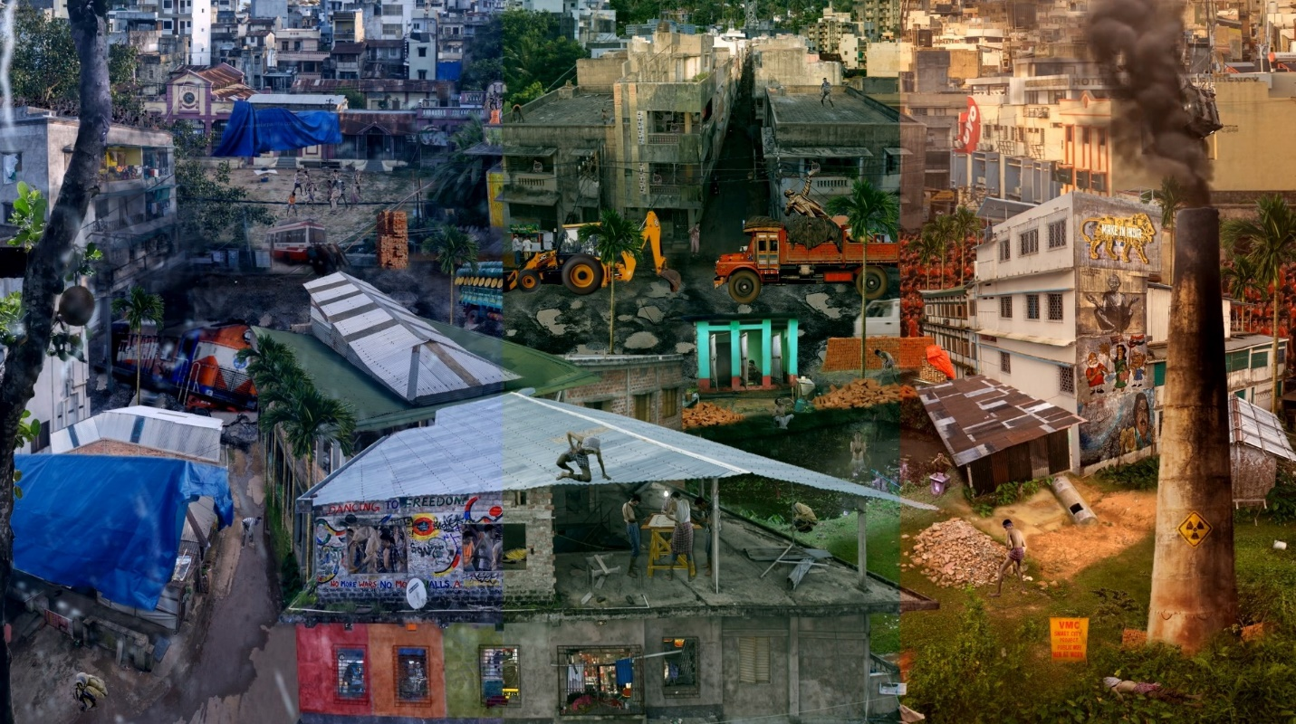
Sabyasachi Bhattacharjee
Homecoming (2018)
Single Channel Video projection

The key purpose of most arts institutions is to provide a framework for young artists to organically develop thoughts and ideas that eventually take form in their artistic practice. It is far from a dogmatic method of instruction that dictates what should and should not be done. The realm of arts continues to remain an inclusive space that consistently evolves to accommodate newer languages of expression, which are not merely restricted to formalistic aspects such as mediums, methods, and presentations, but also include alternative thoughts and critical discourse that challenge notional understandings. With the readily available free-space and easy access to knowledge sources, the academy nurtures ideation and functions as a tightly knit community of like-minded art makers. Despite varied creative agendas, several challenges faced by every student and artist at the institution are mutual. United by common opportunities as well as challenges, artists while at the institution, learn to form alliances of knowledge and skill sharing.
It is interesting to observe how young artists work with or around the politics and concerns that define their creative process outside the comfort of the academy. This process of negotiating personal politics, professional networks, and their own craft, for a freshly independent artist is the primary question that drives the curation of the Embark series of exhibitions at Gallery Ark. An important aspect of being able to produce work while holding one’s conceptual ground is to be able to maintain a steady momentum of work. Therefore, the exhibition encourages artists to showcase works that they have produced in the year since they have graduated from the institute.
The exhibition also paves the way for a discussion around the perennial question of “what makes an artist?”. There are several subjective responses to this question, including having an education in the arts, or gaining commercial and critical recognition. While it seems almost impossible to arrive at a single definitive answer, encouraging this dialogue always leads to new perspectives, which in turn add to the larger dialogues around art practices, the institution, and what comes out of it. An interesting thought at this juncture arises from examining how the present makes use of the past. If such exhibitions function as a platform or means to chronicle the changing trends in a particular premise, then the records emerging from these will eventually document the new identities that emerge, and the ways in which the past can be reassessed.
Another question that this show tries to negotiate is that of the requisite networks of support to build and sustain artistic careers. More specifically, the role of a gallery in creating a conducive ecosystem for young artists. Embark was envisioned with an aim to bring together the freshest talent from the Faculty of Fine Arts at MSU Vadodara. As a major center for art production in India, Baroda is home to a truly diverse range of artists. Embark is positioned as a venue for the youngest of the lot to garner commercial exposure, while playing from home turf.
The exhibition intentionally avoids a thematic binder for the artworks displayed. Instead, it assumes the form of a survey show. While the featured artists deal with a wide range of concerns through their works, the human condition and its relevance to time appears to be a common concern for most. The dominant identity of art from Baroda, as formulated by scholarship, for a long time has been based on the figurative-narrative styles that emerged from the art school here. Several reasons have led to a deviation from that figurative-narrative identity with more and more students at the faculty experimenting with newer modes of presentation. The changes seen in the works produced by young artists from the Faculty reflect an important curve in the changing outlook of the pedagogy at Baroda.
Embark is an annual exhibition that coincides with the Degree Show at the Faculty of Fine Arts, MSU, and thereby provides an opportunity to concurrently view the works of two successive batches of graduates. Embark II features fifteen artists from the batch of 2016–18 and evaluates how traditional art techniques and new media simultaneously find accommodation in art making today. In its humble capacity, the exhibition also sheds light on the kind of practices the Faculty of Fine Arts has been encouraging in the recent past. By way of a symbiotic existence in Baroda, Gallery Ark is invested in the academic and immediate social context of the young artists. The Embark series therefore, holds a special significance to the gallery, and is intended as a platform to further the careers of these artists and explore future collaborations.

